**VILLAGE OF MIDDLEBURGH, NEW YORK**

**REQUEST FOR PROPOSALS (RFP)**

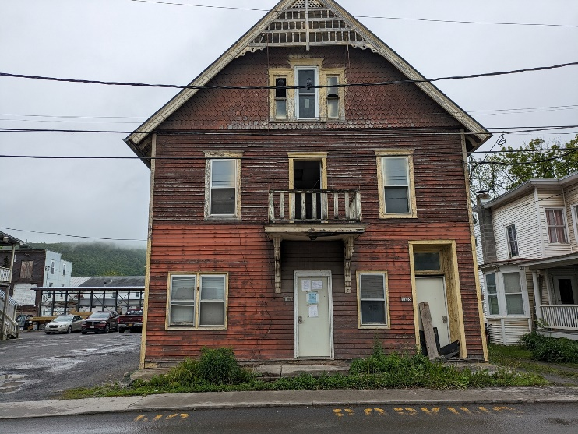The Village of Middleburgh is seeking proposals for the demolition of a publicly owned residential building at 111 Railroad Avenue, a 2,800 square foot, two-story structure that will be removed to provide public parking for businesses and residents on Railroad Avenue.

Submitted proposals should contain the following information: bidded cost and timeline for destruction. To receive more information about the project from a Village official, please contact Village Mayor Timothy Knight by email at [timothycknight93@gmail.com](mailto:timothycknight93@gmail.com) or via cell phone at 518-231-1465.

Upon sampling conducted by Ambient Environmental, Inc. on behalf of the Village, it was found that the structure at 111 Railroad Avenue has no positive materials when tested for asbestos. Lab results indicated only trace amounts were detected, which must be conveyed to any contractors working on these materials for compliance with the *Occupational Safety and Health Administration 1926.1101*. No asbestos abatement is required. Preliminary results are available upon request to the Village Clerk or by accessing them on the Village Website at the following url: <https://www.villageofmiddleburgh.com/village/111-railroad-avenue-rfp-project/>

If awarded this project, the awardee will have to abide by the terms and conditions of being a High Hazard Contractor as required by the Village’s municipal insurer NYMIR. A copy of the terms is available upon request to the Village Clerk or by accessing them on the Village Website at the following url: <https://www.villageofmiddleburgh.com/village/111-railroad-avenue-rfp-project/>.

Per Village Resolution 12-2024 (Procurement Policy), Section 3, Clause B, all purchase contracts of over $20,000 (including contracts for service work, but excluding any purchase contracts necessary for the completion of a public works contract pursuant to article eight of the labor law) may be awarded on the basis of best value, as defined in NY State Finance Law Section 163,1 to a responsive and responsible bidder or offerer in the manner provided by GML Section 103.

Proposals must be received by the Village Clerk, P.O. Box 789, Middleburgh, NY, 12122, by Friday, August 1 at 2:00 PM. The Village Board of Trustees reserve the right to reject any and all proposals submitted or to accept any proposal which, in the opinion of the Board, will be in the best interest of the Village of Middleburgh.

**Village Board of Trustees**

**Village of Middleburgh**